CST 415 – Lecture 7
Wilsonville, Fall 2017

DNS – Domain Name System
CNP 3.2.1, Pg. 32
ICN 7.7, Pg. 169

DNS is a service created to make it easier for humans to remember machine addresses
Attach a human friendly name to a machine, and then lookup IP address by name
Over time, names have become more important…
Names are stable, while IP addresses change or are assigned dynamically
Names have value in of themselves, for their brand recognition

Early name resolution was with a shared hosts.txt file
Names were registered with a central authority, who updated the master file
All servers on the interet regularly retrieved a copy of the master file

To make this scale, need…
Easy way to add names and update addresses
To avoid collisions and keep names unique

Names became heirarchical, with root names being suffixes, like .org, .gov, .edu, .com…
Managed by ICANN, icann.org, Internet Corporation for Assigned Names and Numbers
Each node in the heiarchy is managed by a different entity, for example…
.edu is managed by Educause, operated by Verisign
https://en.wikipedia.org/wiki/Educause
https://en.wikipedia.org/wiki/.edu

Each fully qualified name is like… www.oit.edu, where…
“www” is a server name, “oit” is a sub-domain and “.edu” is a root domain
Each part starts with a letter and can contain only letters, numbers and dashes

Name servers are responsible for a domain and answering two types of queries:
Lookup IP address by name
Lookup name server by sub-domain
A root name server is responsible for a root domain, like “.edu”
Using DNS to get the address for a fully qualified name requires recursively navigating many name servers for sub-domains, until the final address is found.
Resolvers are front line name servers that do this recursive search on behalf of clients
Resolves can cache popular name/address pairs to speed up resolution
The DNS protocol is used to by clients to talk to name servers
It sits on top of UDP

A DNS request typically has the following parts:
DNS Header – ID, length, type of request, etc.
Question – question to be answered

A DNS response typically has the following parts:
DNS Header – Request ID, lenth, type of response, etc.
Question – original question that was asked
Answer – filled in answer to question

The Question and Answer are “Resource Records” of various types
“A” type resoure records contain host names and IPv4 addresses
“NS” type resource records contain name server addresses for sub-domains

Use the “nslookup” app on Windows to explore DNS records, for example…
nslookup -type=A www.oit.edu
nslookup -type=ns www.oit.edu

DNS is a protocol at which layer?
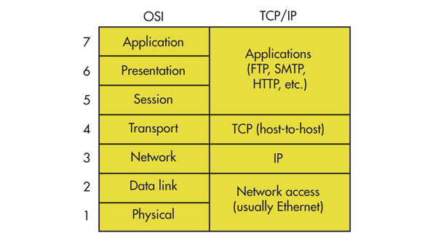

ARP – Address Resolution Protocol
CNP 5.2.2, Pg. 151
ICN 7.8, Pg. 173

ARP is a protocol for determining which machine on a LAN has a specified IP address

When a router or host has an IP packet to send to another machine on the local LAN, it needs to know what LAN address to use

The first stop is the local “ARP Cache” on the sending host
If the mapping between IP address and LAN address in the cache, good to go!
If not, then the host can use the ARP protocol to discover the needed LAN address

The originating host sends an ARP broadcast on the LAN, with the destination IP address
The host with that destination IP address will reply directly to the originating host
The originating host will then have the destination hosts LAN address and can then…
- Add the destination host’s IP address and LAN address to it’s ARP cache
- Forward the IP packet to the destination host on the LAN
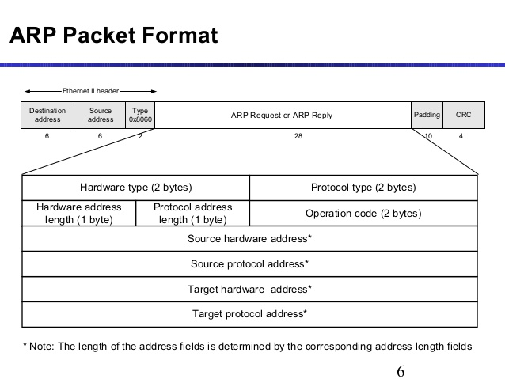
https://upload.wikimedia.org/wikipedia/commons/7/71/Arp-6-638.jpg

You can look at the ARP cache on your computer with “arp -a”.

ARP is a protocol at which layer?

